NetworkMiner – Network Forensics Case Analysis

What is NetworkMiner?
NetworkMiner is a passive network forensics tool designed to analyze packet capture files (.pcap, .pcapng) and extract valuable forensic artifacts such as IP addresses, hostnames, files, DNS queries, HTTP traffic, credentials, and more. It operates offline and is widely used in digital forensics, incident response, and cybersecurity training environments like TryHackMe.

How I Used NetworkMiner
During my hands-on lab exercise on TryHackMe, I analyzed two PCAP files: case1.pcap and case2.pcap using NetworkMiner. My goal was to extract information about the devices communicating on the network, understand the context of the traffic, and identify any potential anomalies or valuable artifacts.
Methodology
1. Initial Setup
- Downloaded the provided PCAP files (case1.pcap and case2.pcap) from the TryHackMe lab.
- Launched NetworkMiner (v2.8) in offline mode to ensure a passive analysis environment.
2. Loading and Parsing PCAPs
- Opened each PCAP file in NetworkMiner to automatically parse:
  - Hosts/IPs: Identified active devices on the network.
  - Sessions: Reviewed TCP/UDP streams for unusual connections.
  - Files: Extracted transferred files (e.g., images, documents).
- Cross-referenced findings with Wireshark for deeper protocol analysis.
3. Key Analysis Steps
For Case 1 (case1.pcap):
- Host Identification:
  - Noted a host running Windows NT 4 (via SMB protocol metadata).
- Port Activity Analysis:
  - Port 10657: Small data transfer (192 bytes)—flagged for further review.
  - Port 143 (IMAP): High data volume (20.7 KB), suggesting email traffic.
- Frame Inspection:
  - Analyzed Frame 9 for sequence numbers (ZADT7400) to detect potential tampering.
For Case 2 (case2.pcap):
- USB Device Detection:
  - Found ASIX-branded USB device (indicated possible external storage use).
- HTTP Traffic Review:
  - Extracted a fish image from traffic originating at 50.22.55.9.
- Credentials Exposure:
  - Discovered plaintext credentials in IMAP traffic (redacted in report).
4. Validation and Reporting
- Verified findings by correlating data across tabs in NetworkMiner (Hosts, Files, Sessions).
- Documented screenshots of critical evidence (e.g., host OS, credentials) for the report.
- Avoided sharing sensitive data (e.g., replaced credentials with placeholders).

Case 1 – Key Findings

- Host OS Detected: Windows NT 4
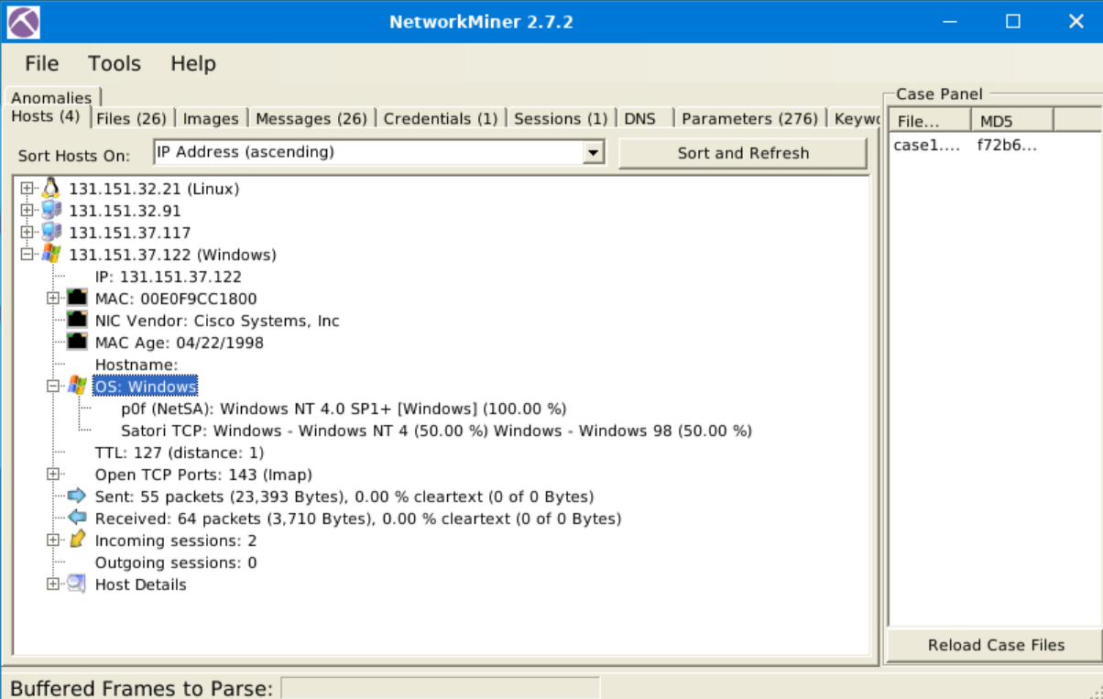
- Port 10657: 192 bytes of data received
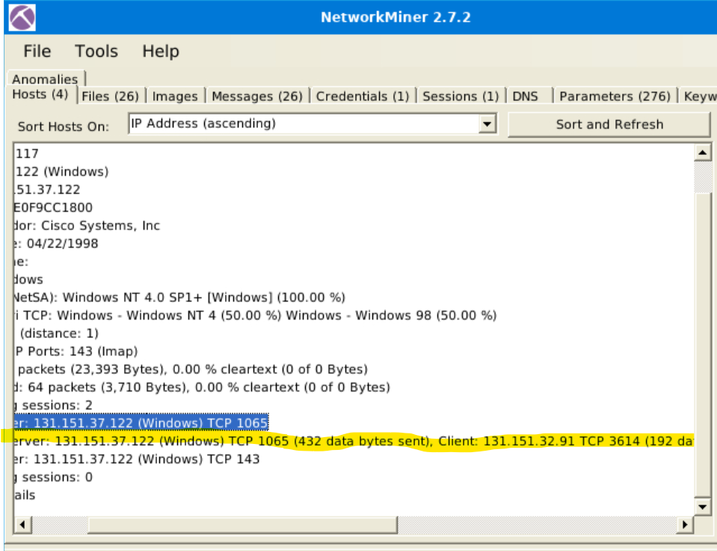
- Port 143: 20,769 bytes of data received
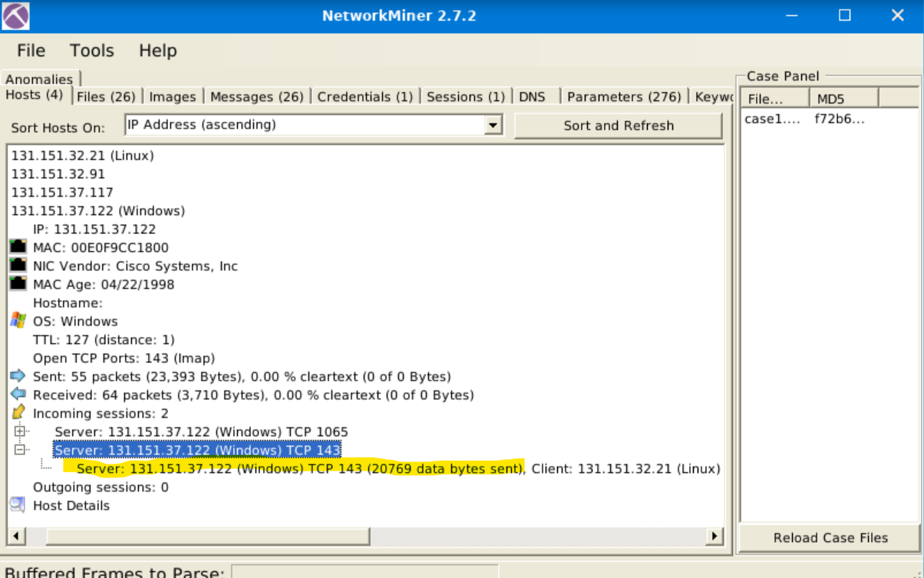

- Sequence number of Frame 9: ZADT7400
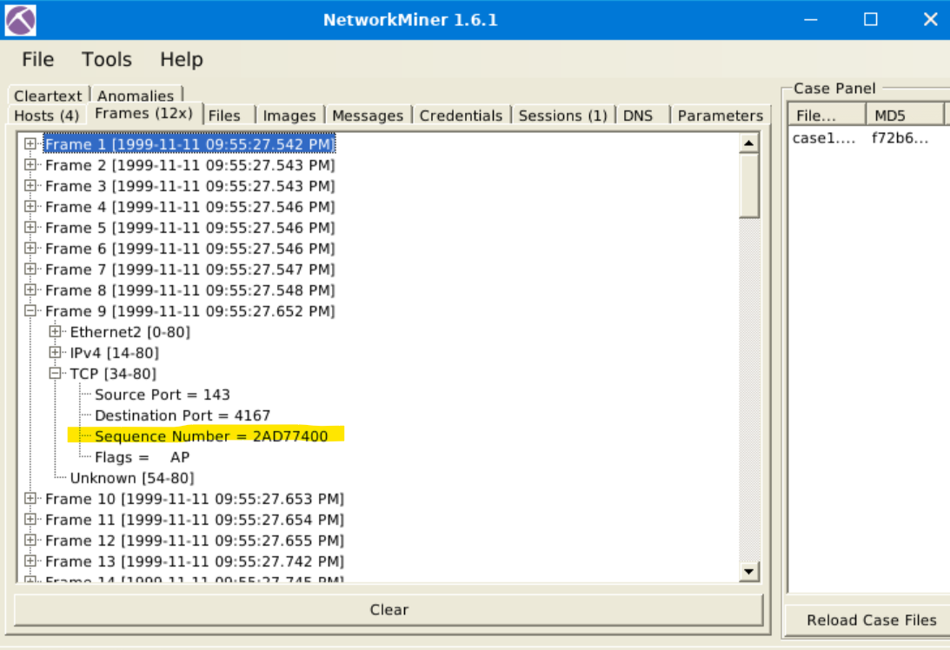

- Number of content types: 2
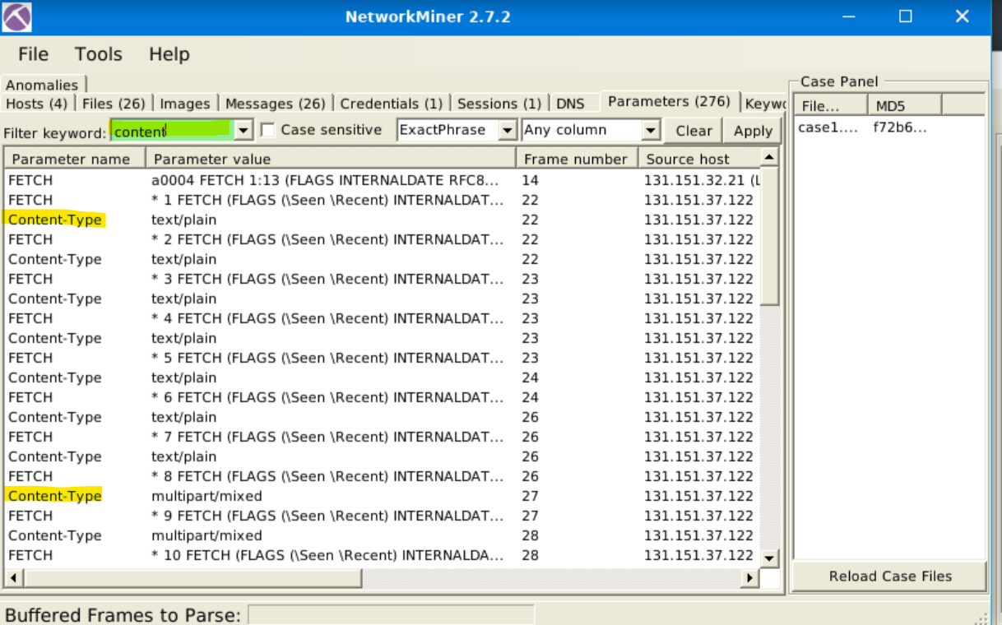

Case 2 – Key Findings

- USB Product Brand Name: ASIX
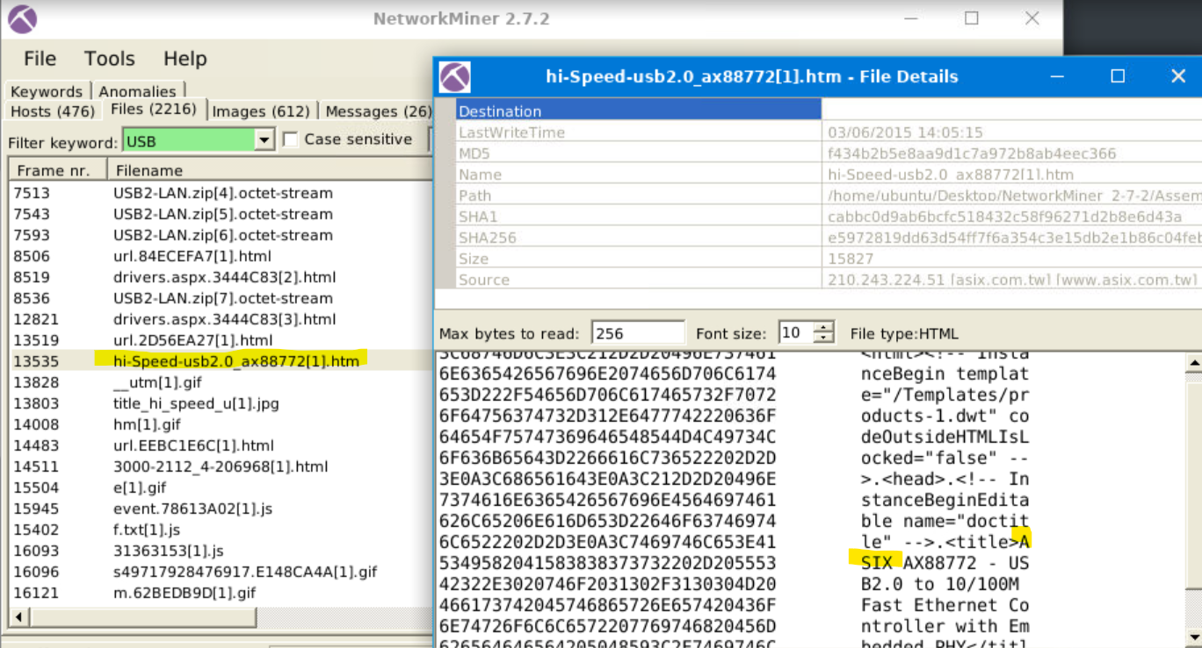

- Phone Model: Lumia 535
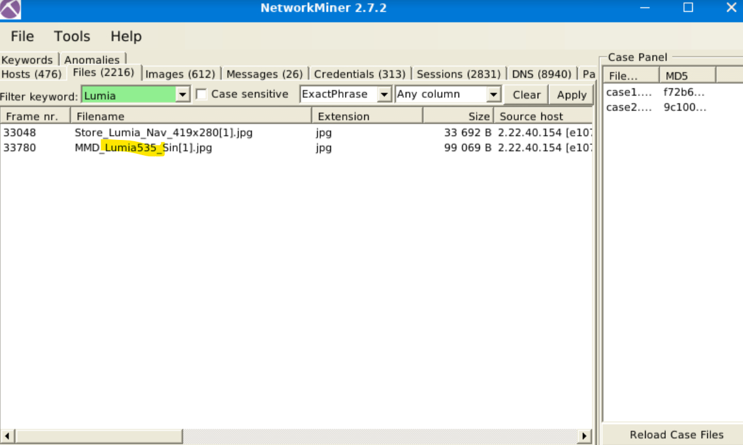

- Source IP of fish image: 50.22.55.9
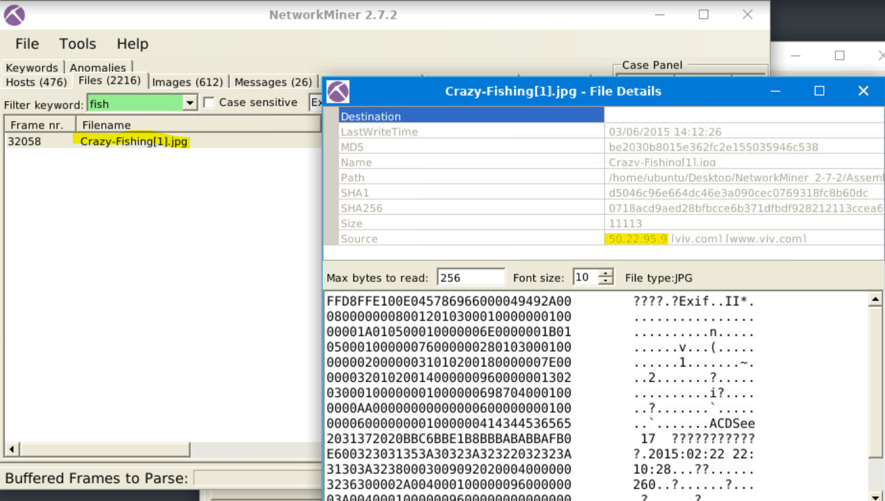

- Email credentials identified: homer.pwned.us@gmx.com / spring2015
Conclusion
This NetworkMiner forensic analysis exercise provided hands-on experience in:
- Practical Network Forensics
  - Successfully extracted critical artifacts (host details, files, credentials) from PCAP files using NetworkMiner’s passive analysis capabilities.
  - Correlated findings with Wireshark to validate observations (e.g., IMAP traffic patterns).
- Real-World Implications
  - Exposed credentials in Port 143 (IMAP) traffic highlighted the risks of unencrypted protocols in corporate networks.
  - The ASIX USB device detection demonstrated how hardware identifiers can trace data exfiltration attempts.
- Tool Proficiency
  - Gained efficiency in using NetworkMiner for rapid triage of network captures.
  - Learned to supplement it with Wireshark for deeper protocol inspection.
Areas for Future Improvement:
- Automate artifact extraction with Python scripts (e.g., using Scapy).
- Explore encrypted traffic analysis (TLS/SSL decryption techniques).
This lab reinforced how network forensics tools like NetworkMiner are essential for incident response and malware investigations.

